Assignment #1
Due: 1 pm, Friday, January 31st

Open the file Student Survey Data.xlxs. This file is in the Data folder for the course on Brightspace and on the P: drive.

- Create a new spreadsheet called Student Expenses.xlxs.

From the Student Survey Data file copy columns ID, q7, q20, q21, q27, 28, q29, q30, q53 and q56 into your new spreadsheet Student Expenses.

It should look like:
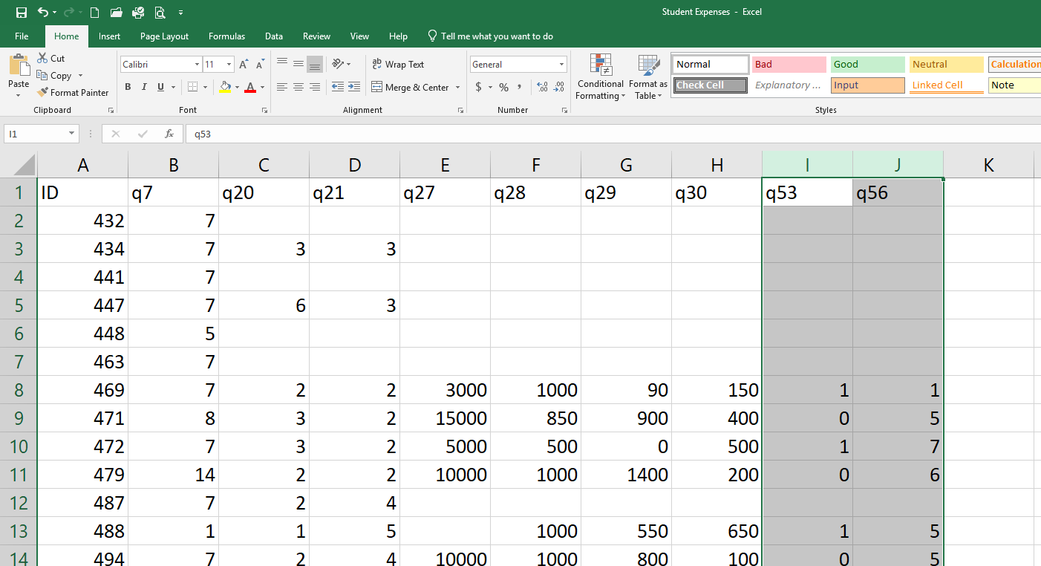

Rename this tab Data

Add a new tab and name it Dictionary

From the Student Survey Data file, go o the Question Numberings tab and copy the rows that give the explanations of each of the headings. For example, for q7 it shows:

q7 | In which province or territory did you complete high school? (If you attended high school in more than one province, please select the one in which you <u>finished</u> high school.)

Copy this to your Dictionary tab and do the same for each of the other questions.

Rename your variables in the Data tab as q7=”Province”, q20=”Worth$”, q21=”Concern$”, q27=”Tuition”, q28=”Books”, q29=”Living”, q30=”Other”, q53=”Gender” and q56=”ParentEd”.

Make your data file into an Excel Table.

Insert a column in your Dictionary and add your relabeled variable names for each variable.

Take a screen shot of your Data tab and print it.

- In your Data tab, insert a column to the left of “Province”.

Label it “Home”.

Go to the right of your data and skip one column (go to column M). ). If you don’t skip a column, Excel will consider anything you add to be part of your Table. You don’t want this to be part of the dataset.

Create a look-up table to convert numeric values for Province to text as follows:

Province
1 | Canada
2 | Canada
3 | Canada
4 | Canada
5 | Canada
6 | Canada
7 | Nova Scotia
8 | Canada
9 | Canada
10 | Canada
11 | Canada
12 | Canada
13 | Canada
14 | International

Use VLOOKUP and the above table to recode Home for the corresponding values of Province.

In a similar manner create new columns beside Gender and ParentEd and recode these numeric columns with text columns using the following look-up tables:

Gender |  | ParentEd
0 | Male | 1 | High School
1 | Female | 2 | College
 |  | 3 | Bachelors
 |  | 4 | Advanced
 |  | 5 | Advanced
 |  | 6 | Advanced
 |  | 7 | Don’t Know

Take a screen shot of the Data tab and print it.

Update your Dictionary by adding three new rows to explain what these 3 new variables represent. Use your own words.

Take a screen shot of the Dictionary and print it.

- Select any of the variables and do a custom sort. Excel may call this “Sort by Color”. Sort your data first by Concern$ and second by Tuition. The first sort should be Largest to smallest and the second sort should be Smallest to largest.

If you did it correctly, the first several entries should show as “6” for Concern$ and then the Tuition values should appear in increasing order.

Take a screen shot and print it.

- To return the data set to its original sequence, sort the data based upon ID smallest to largest.

Go to Living and filter on those students who have a monthly Living cost of less than or equal to $200. These students are likely living at home.

Take a screen shot and print it.

Clear the filter before continuing.

- Insert a new column after the column labelled “Other”. Label it Total. This will be the total costs for 8 months. The Tuition and Books costs are per academic year, but the Living and Other costs are per month. Create a formula to calculate the total costs for 8 months.

Excel will treat blanks as zero which could mess up our analysis. Those that responded should at least give us a value for Tuition. My spreadsheet has Tuition in column F, so build your formula as

=IF(F2=””,””,F2+G2+8*H2+8*I2)

Go to the Design tab and indicate that you want a Total Row.

Scroll down to the Total Row and find the average for Tuition, Books, Living, and Other. What are these averages?

Using these averages, calculate what you think the average total cost should be. Remember that Living and Other are monthly costs whereas Tuition and Books are for 8 months. What is your answer?

Now find the average for Total expenses by using the Average function in the Total Row. What do you get? What explanation do you have for why it is different?

- We would like to categorize Living expenses as Very low, Low, Average, High and Very High as follows:

Living | Category
Under $200 | Very Low
$200 - $499 | Low
$500 - $799 | Average
$800 - $1199 | High
$1200 and above | Very High

Create a new variable to reflect these categories and use VLOOKUP to assign the values.
Take a screen shot of the first few rows and print it.

- Use the Histogram function in Excel to construct a frequency distribution and corresponding histogram for Living expenses. The bins should be in increments of $200.

Print a copy of the frequency distribution and of the histogram. You do not need to remove the gaps between the columns or do any special formatting.

